**The Constitution (ratified September 17, 1787)**

Article I: **ALL legislative powers**, herein grated, shall be vested in a Congress of the United States, which shall consist of a Senate and House of Representatives.

Article II: **The executive power** shall be vested in a President of the United States of America. He shall hold his office during the term of four years, and, together with the Vice-President, chosen for the same

term.

Article III: **The judicial power** of the United States shall be vested in one Supreme Court, and in such Inferior Courts as the congress may from time to time ordain and establish.

**What are the three branches of government? Why are they separated?**

**The Bill of Rights (written September 25, 1791)**

**Amendment I**:

Congress shall make **no law respecting an establishment of religion**, or prohibiting the free exercise thereof; or abridging the **freedom of speech**, or of the **press**; or the right of the people peaceably to **assemble**, and to **petition** the Government for a redress of grievances.

**What are the five freedoms in the first Amendment? Which do you think is the most important? Why?**

**Boston Tea Party (1773)**



As a protest against a tax placed on imported tea by the British crown, a group of American colonists, led by Samuel Adams, staged the Boston Tea Party. **They did not like that the government was interfering with the free market of tea**. On December 16, 1773, the colonists, some dressed as Native Americans, boarded three British ships and tossed the tea cargo into Boston Harbor.

**Why did the colonists destroy the tea? What was the effect of this event?**

**Declaration of Independence (July 4, 1776)**

We hold these truths to be self-evident (clearly true), that all men are created equal, that they are endowed (gifted) by their Creator with certain unalienable **rights, that among these are life, liberty and the pursuit of happiness**.

**That to secure these rights, governments are instituted (created) among men**, deriving (getting) their just powers from the consent of the governed (the people).

That whenever any form of government becomes destructive to these ends, it is the **right of the people to alter or to abolish it, and to institute new government**, laying its foundation on such principles and organizing its powers in such form, as to them shall seem most likely to affect their safety and happiness.

**What is the purpose of government? What can the people do if the government does not fulfill that purpose?**

**The Boston Massacre (1770)**

Tensions between the American colonists and the British were already running high in the early spring of 1770. **The British had increased their presence of soldiers throughout the colony to try to keep order and stop crime.** Late in the afternoon, on March 5, a crowd of jeering Bostonians slinging snowballs gathered around a small group of British soldiers guarding the Boston Customs House. The soldiers became enraged after one of them had been hit, and they fired into the crowd, even though they were under orders not to fire. Their shots hit and killed five civilians in an event that has come to be known as the Boston Massacre.

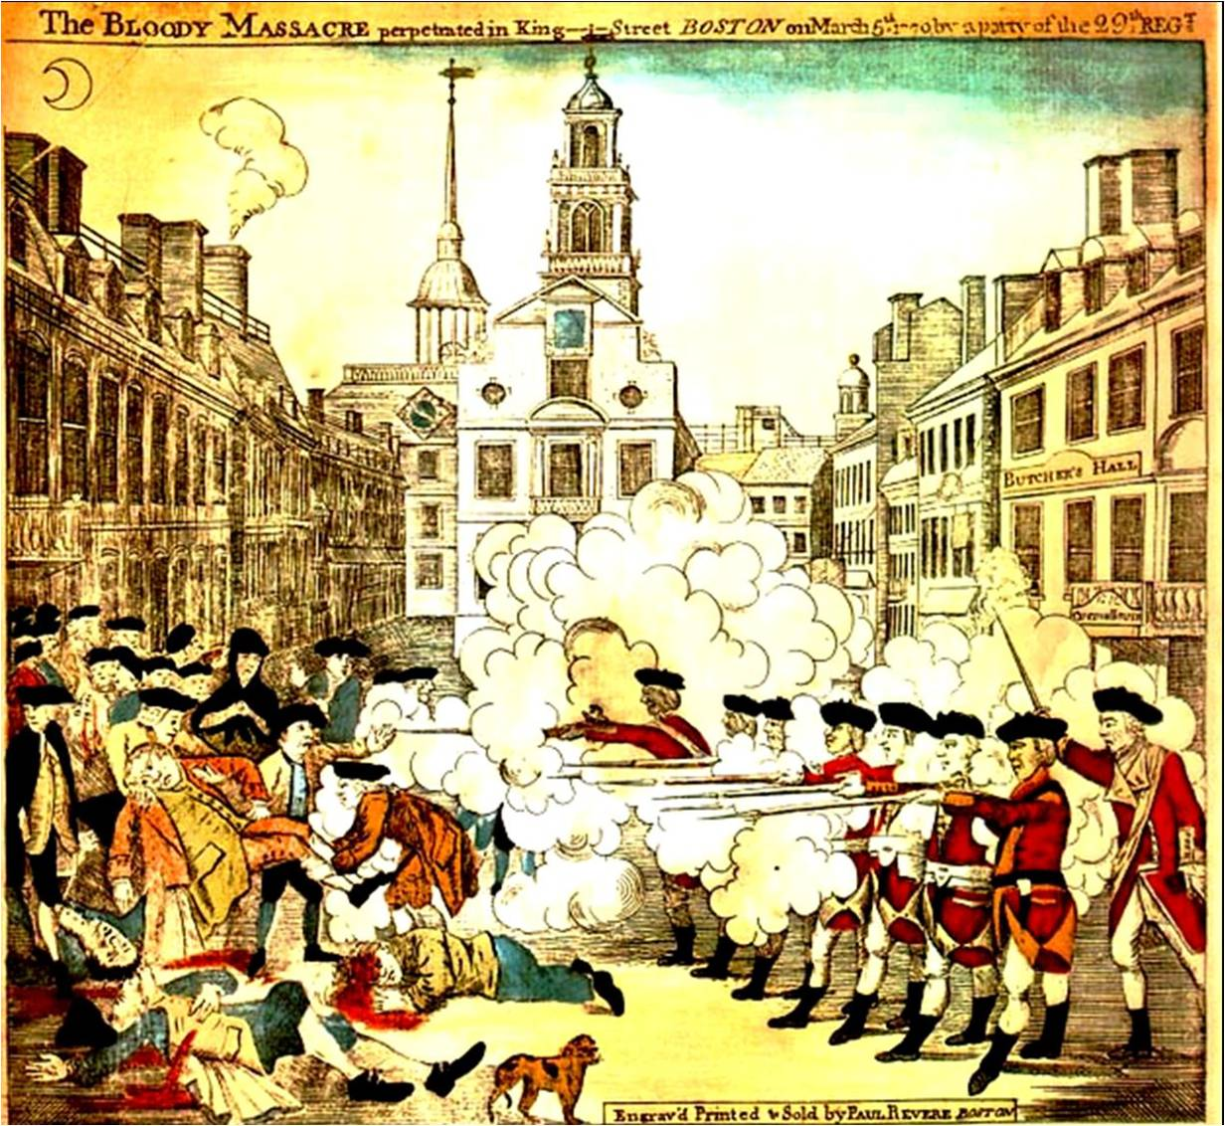

**Why did this event happen? What was its impact?**

**Letter from Abigail Adams to John Adams (March 31, 1776)**

“I long to hear that you have declared an independency. And, by the way, in the new code of laws which I suppose it will be necessary for you to make, **I desire you would remember the ladies** and be more generous and favorable to them than your ancestors. Do not put such unlimited power into the hands of the husbands. Remember, all men would be tyrants if they could. If particular care and attention is not paid to the ladies, we are determined to foment a rebellion, and **will not hold ourselves bound by any laws in which we have no voice or representation**.”

**What was Abigail Adams’ wish? Why don’t you think the new government gave those rights to women?**