Choosing Your “AP Adventure” Project (Unit III) - 600 CE – 1450 CE
Using material from your readings and our class discussions, create 2 products from the list below. You will have the entire class period to work on these, but they WILL be due today.
You MUST stay within the Unit III time frame!

Illustrated/Annotated Map
10 points / 45 Minutes
.DOC .PDF
Your task: Create a map of a historical event that includes illustrations and captions highlighting key information. Your map should be neat and colored.
Your map must include:
ROUGH DRAFT
1. The basic map of your event.
2. Choose a minimum of 5 specific details of the event that you want to represent on your map.
3. Either a picture or a 3 sentence caption for 5 different events. Each item should be in the proper location on the map.
4. A legend and relative scale.
*Number each piece on your rough draft and show it to your teacher before moving on.*
FINAL DRAFT
5. All of the above pieces neatly colored on white paper.

Illustrated/Annotated Timeline
10 points / 45 Minutes
.DOC .PDF
Your task: Create a timeline of a historical period that includes illustrations and captions highlighting key information. Your timeline should be neat and colored.
Your map must include:
ROUGH DRAFT
1. The basic timeline of your historical period.
2. Choose a minimum of 10 specific events that you want to represent on your timeline.
3. A 2-3 sentence caption for each event along with the correct date when it occurred.
4. A picture for at least 4 of the events.
*Number each piece on your rough draft and show it to your teacher before moving on.
FINAL DRAFT
5. Do your final draft on white paper and use color throughout.

Remote Control
10 points / 45 minutes
.DOC .PPT .PDF
Your task: Create a 3-night Prime-Time TV schedule for a channel about the current unit by coming up with TV shows that would reflect their culture.
Instructions:
1. Create a TV Guide chart on your own paper using the template below.
a. Create a title for your channel in the top section.
b. Create six TV shows that would be on your channel.
c. For each show indicate what type of show it would be (game show, reality, comedy, etc.)
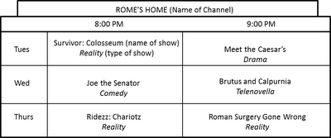
2. Write show descriptions for 4 of your shows you created above. These descriptions must be at least three sentences and include historical information and facts related to the show. An example is provided below.
Example:
Ridezz: Chariotz (Reality): Join our host Ben Hur as he travels Rome looking for the hottest Chariots. This week Ben finds a tricked out racing chariot actually used in the Circus Maximus. You won’t believe the amazing (and maybe illegal) additions made to this ride!

Trading Cards
10 points / 45 minutes

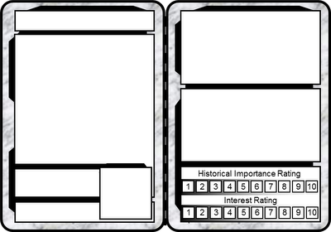
.DOC .PDF .PPT
Your Task: Create 3 historical trading cards based on important people, events, or objects we learned about this unit. Collect ‘em all!
Instructions:
1. Carefully trace the template below 3 times onto one side of a blank white paper.

2. Use the model below to fill in your cards.

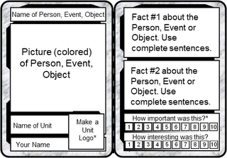
*The Unit Logo is any picture or symbol that represents the unit. This should be the same on all three cards.
*For the rating bars color in the boxes up to the rating you would give. A 10 means the world would not exist without it. A 1 means the world wouldn’t change at all without it.

Legal Brief
10 points / 45 minutes.DOC .PDF
Your task: As a defense lawyer your job is to prove your client is not guilty of crimes he/she is accused of. Write a legal brief defending a particular person or group in history. You will create an opening statement and describe what witnesses you would call and what you would ask them.
Instructions: Copy and complete the sheet below
Name of Defendant:____________________________________________
Crime Accused of: _______________________________________________________
I. Opening statement- Write one paragraph summarizing the issues at hand and to introduce what you will present as evidence to defend your client.
II. Witnesses- Explain who would you call to testify for or against your client.
1. First witness to be called: _________________________________________________
i. First question
ii.Second question:
What will this witness say that will help/hurt your client?
2. Second witness to be called: ______________________________________________
i. First question:
ii. Second question:
iii. What will this witness say that will help/hurt your client?

Song Rewrite
10 points / 45 minutes
.DOC
Your task: Rewrite the lyrics to a popular song to make it about an event or civilization from history.
Instructions:
1. Print or write out the lyrics to a popular song that is appropriate for school.
2. Rewrite the song with new lyrics that about all about one event, person or civilization from history. It must rhyme!
3. You must change the entire song and it should not be repetitive (the chorus, of course, can repeat).
4. Turn in both the original lyrics and your rewritten ones.

Introduction Speech
10 points / 45 minutes
.DOC .PDF
Your task: Often when a famous person is about to give a speech they are first introduced by someone else with a short speech. Write and recite a short introduction speech for a famous figure.
Your speech must:
-Be about 1 minute in length (approximately 2 paragraphs written should do it).
-Include key details and information about the figure.
-Be inspiring (if you are introducing Constantine you’d likely want to leave out the fact that he was suspected of killing his wife.)
-Make the person sound important.
After writing your speech meet with your teacher to set up a time to present it to the class.
Example:
Ladies and gentlemen of Rome, it is my pleasure to introduce to you today a man who rose up in our time of need. This is a man who can and will save the Roman Empire. He is not just a squabbling senator; no, he is a warrior! What other man do you know who killed an elephant?! This is the man who led the Roman army to victory time and time again. He conquered Gaul and grew our mighty land all the way to the Atlantic Ocean! This is the man who out of the goodness of his heart adopted his nephew Octavius as his own son.
Today I am proud to introduce the only Roman leader who truly cares about you – the people. He got rid of the awful, wasteful Republic and replaced it with the new and mighty Empire and the one person who could hold it all together. Ladies and gentleman, here he is, JULIUS CAESAR!!!

Dear Diary
10 points / 45 minutes
.DOC .PDF
Your task: Write a series of diary entries as if you were a person living through a historical event. Keep in mind this is not a report on the event but the thoughts and feelings of someone living through it. Your diary should include any key terms or people involved with the event in some way.
Instructions:
1. If one has not been assigned, choose what type of person you will be (rich, poor, king, peasant, soldier, etc)
2. Write a one-paragraph entry about the beginning of the event. Include the date. Briefly described how the event began (if your person would know).
3. Write a one-paragraph entry about the middle of the event. Include the date. Mention whether things are better than the beginning or not.
4. Write a one-paragraph entry about the end of the event. Include the date. Describe your character’s feelings about the event now that he/she has lived through the whole thing.

