Imperialism In India DBQ

Answer each question following a source on a separate sheet of paper in 2-3 well-developed sentences.

Document 1 –Adapted from British historian, J.A.R. Marriott’s book, The English in India.

British brains, British enterprise, and British capital have changed the face of India. Means of communication have been developed. There are great numbers of bridges, more than 40,000 miles of railway, and 70,000 miles of paved roads. These testify to the skill and industry of British engineers. Irrigation works on a very large scale have brought 30 million acres under cultivation. This has greatly added to the agricultural wealth of the country. Industrialization has also begun. India now has improved sanitation and a higher standard of living. It has a fine transport system and carefully thought-out schemes for relief work. Because of these things famines have now almost disappeared.

- Identify five benefits of Imperialism cited by this author.

Document 2 – From India: A Restatement by British writer Sir Reginald Couplan

British rule brought with it from the West certain standards of humanity that Indian society had not yet reached. Early action was taken to stop infanticide [the practice of killing baby girls] . . . The slave trade was ended and the owning of slaves was forbidden . . . One result of the new order was a steady rise in the value of India’s export trade.

- How was Indian society improved according to this author?

Document 3 –From The Discovery of India, by Jawaharlal Nehru
This process continued throughout the 19th century. Other old Indian industries – shipbuilding, metalwork, glass, paper – and many crafts were broken up. Thus the economic development of India was stopped and the growth of new industry was prevented . . . A typical colonial economy was built up. India became an agricultural colony of industrial England. It supplied raw materials and provided markets for England’s industrial goods. The destruction of industry led to unemployment on a vast scale . . . The poverty of the country grew. The standard of living fell to terribly low levels.

- What negative effects of imperialism does Nehru point out?

Document 4 – Mohandas Gandhi
You English committed one supreme crime against my people. For a hundred years you have done everything for us. You have given us no responsibility for our own government.

- What is Gandhi’s criticism of imperialism?

Document 5 –Adapted from O.P. Austin’s “Does Colonization Pay?” The Forum, January 1900

Modern progressive nations [European colonizers] . . . seek to control “garden spots” in the tropics. Under their direction, these places can yield the tropical produce that their citizens need. In return the progressive nations bring to the people of those garden spots the foodstuffs, and manufacture they need. They develop the territory by building roads, canals, railways, and telegraphs. The progressive nations can establish schools and newspapers for the people of the colonies. They can also give these people the benefit of other blessings of civilization which they have not the means of creating themselves.

- What benefits did the British bring to Indians that the author believes could not be developed on their own?

Document 6 – Adapted from a speech by Dadabhai Naoroji, an Indian

To sum up the whole, the British rule has been—morally, a great blessing; politically peace and order on one hand . . . on the other, materially, impoverishment . . . . The natives call the British system . . . “the knife of sugar.” That is to say there is no oppression, it is all smooth and sweet, but it is the knife, nevertheless.

Europeans [the British] occupy almost all the higher places in every department of government. . . . . Natives, no matter how fit, are deliberately kept out of the social institutions started by Europeans. . . .All they [the Europeans] do is live off of India while they are here. When they go, the carry all they have gained.

- How was British imperialism both a blessing and curse for India?

Document 7 – An advertisement for Lipton Tea grown in South Asia
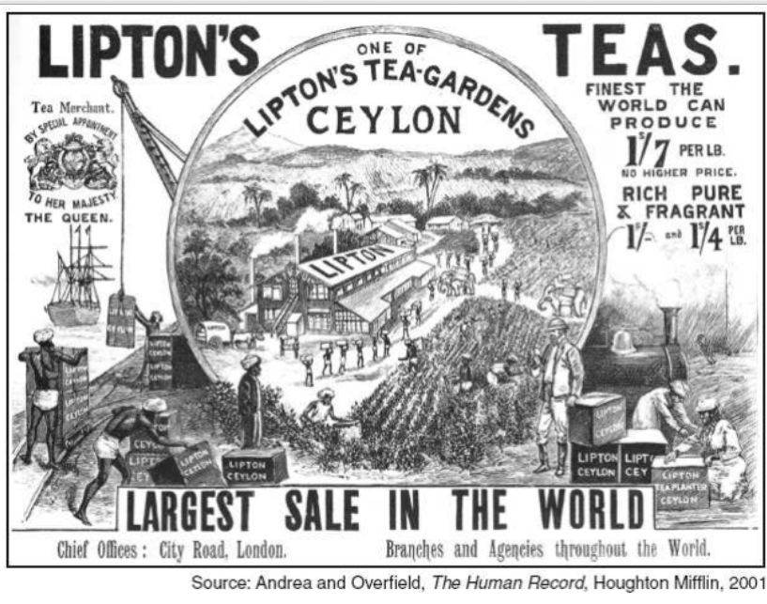

- What does this reveal about how the native population was viewed by the British?

