The Zimmerman Telegram – Teaching with Documents

Historical Background
Between 1914 and the spring of 1917, the European nations engaged in a conflict that became known as World War I. While armies moved across the face of Europe, the United States remained neutral. In 1916 Woodrow Wilson was elected President for a second term, largely because of the slogan "He kept us out of war." Events in early 1917 would change that hope. In frustration over the effective British naval blockade, in February Germany broke its pledge to limit submarine warfare. In response to the breaking of the Sussex pledge, the United States severed diplomatic relations with Germany.
In January of 1917, British cryptographers deciphered a telegram from German Foreign Minister Arthur Zimmermann to the German Minister to Mexico, von Eckhardt, offering United States territory to Mexico in return for joining the German cause. This message helped draw the United States into the war and thus changed the course of history. The telegram had such an impact on American opinion that, according to David Kahn, author of The Codebreakers, "No other single cryptanalysis has had such enormous consequences." It is his opinion that "never before or since has so much turned upon the solution of a secret message." In an effort to protect their intelligence from detection and to capitalize on growing anti-German sentiment in the United States, the British waited until February 24 to present the telegram to Woodrow Wilson. The American press published news of the telegram on March 1. On April 6, 1917, the United States Congress formally declared war on Germany and its allies.
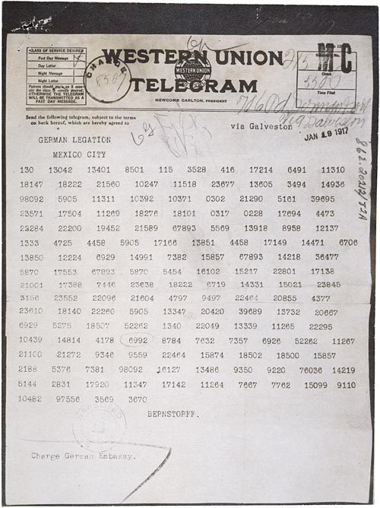
1. What are your initial observations about the telegram that was sent from German Secretary Zimmerman to the Mexican government?
2. How was the telegram sent? Can you make any suggestions as to how the telegram was intercepted or decoded?
3. What geographical advantages would the Germans gain by Mexican entry into the war? What was the role of Japan?
4. What events in 1916 and 1917 contributed to the impact the Zimmermann telegram would have on the American public?
5. Would the United States have remained neutral if the Zimmermann telegram had not been revealed?
The Zimmerman Telegram - Decoded
